## Declaration

I, [Student Name], declare that this assignment, titled [Assignment Title], is my own original work and has not been copied from any other source except where explicitly acknowledged. I have not engaged in plagiarism, collusion, or any other form of academic misconduct in the preparation and submission of this assignment. All sources of information and data used in this assignment have been properly cited and referenced in accordance with the prescribed guidelines. I have not used unauthorized assistance in the preparation of this assignment and have not allowed any other student to copy my work. I am aware that any breach of academic integrity may result in disciplinary action as per the [policies of Monash University](https://www.monash.edu/learning-teaching/priorities-and-programs/assessment-and-academic-integrity/assessments-and-integrity-policy-and-procedure), which may include failing this assignment or the course, and further academic penalties.

Signature: ________________________ Date: _____________________________

## Github Check

Enter your Github details here.

|  |  |
| --- | --- |
| Github Username  *Enter your username here* | <username> |
| **A3 GitHub repository**  *Have you started and shared your assignment repository with your tutor yet?* | No |

## Self-Evaluation

Rate your performance for each criteria. Put a ✅(tick) in the box where you think your work belongs.

|  |  |  |  |  |
| --- | --- | --- | --- | --- |
| **Criteria** | **Exceeds Expectations** | **Meets Expectations** | **Needs Improvement** | **Fail to meet expectations** |
| Executive Summary |  |  |  |  |
| User Personas |  |  |  |  |
| Sitemap |  |  |  |  |
| Wireframes/Low-fidelity Prototype |  |  |  |  |

## Section 1: Executive Summary

**1. Executive Summary (300–400 words)**

*The executive summary provides a clear, concise overview of the project (within the recommended word limits), including the client's objectives, target audience, and the primary goals of the web application. Key details are highlighted effectively. Original research is evident.*

A brief overview of the project, including the client’s objectives, target audience, and the primary goals of the web application. You are expected to be doing some original research on different websites to get fresh ideas about the project.

The Asylum Seeker Refugee Centre (ASRC) is Australia’s largest independent, not-for-profit organisation dedicated to supporting individuals seeking asylum. ASRC provides essential resources such as food, shelter, healthcare, and general supplies, while also offering legal aid, community support, and educational services, including English language classes, homework assistance, and vocational training. As part of its mission to uphold and enhance the physical, mental, and social wellbeing of asylum seekers, ASRC aims expand its digital presence and develop a modern web application to improve service accessibility.

By offering an online platform, ASRC will be better position to provide faster and more accessible aid, enabling more accurate tailoring of support services to individual needs. This web application is designed to serve both asylum seekers and refugees. The digital transformation will enhance this organisation’s ability to assess asylum seekers’ requirements, connect them with the right resources, and assist them in their journey to obtaining refugee status. Additionally, the platform will further assist refugees in adapting to their new environment by offering information and community driven support to ease their transition. The web application will act as a centralised platform to streamline support services, ensuring that both asylum seekers and refugees can access crucial assistance efficiently.

The development of this web application is guided by three core principles: user centric design, clear navigation, and intuitive usability. To ensure an optimal user experience, the website will be structured into four distinct sections: a minimalistic landing page providing a high level introduction to ASRC, its mission, services, and available resources; community pages featuring peer support networks, discussion forums, and social integration initiatives; publications pages granting access to reports, legal guidelines, and informative articles to help users understand their rights and options; and resources pages offering a comprehensive directory of services, including legal assistance, educational programs, and essential supplies.

By implementing a structured and intuitive web platform, ASRC aims to enhance its capacity to support asylum seekers and refugees, fostering a more inclusive and accessible pathway toward stability and integration.

## Section 2: User Personas

**2. User persona**

*The user personas are laid out clearly, highly detailed, well-researched, and provide valuable insights into the demographics, goals, needs, and pain points of the target audience. The personas clearly demonstrate how the web application will address their specific requirements.*

**Persona 1**

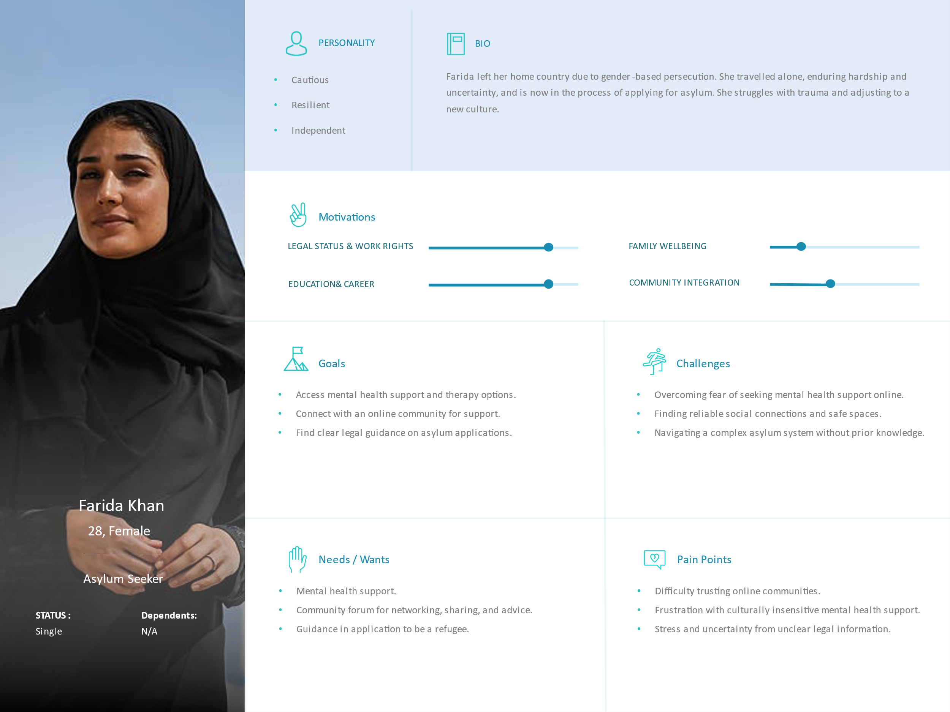

* How the web application addresses needs:
  + Provides an online counseling platform and mental health and self-help resources.
  + Provides a community-based forum for networking, sharing, and advice.
  + Provides detailed step-by-step asylum guidance resources as well as legal aid resources.

**Persona 2**

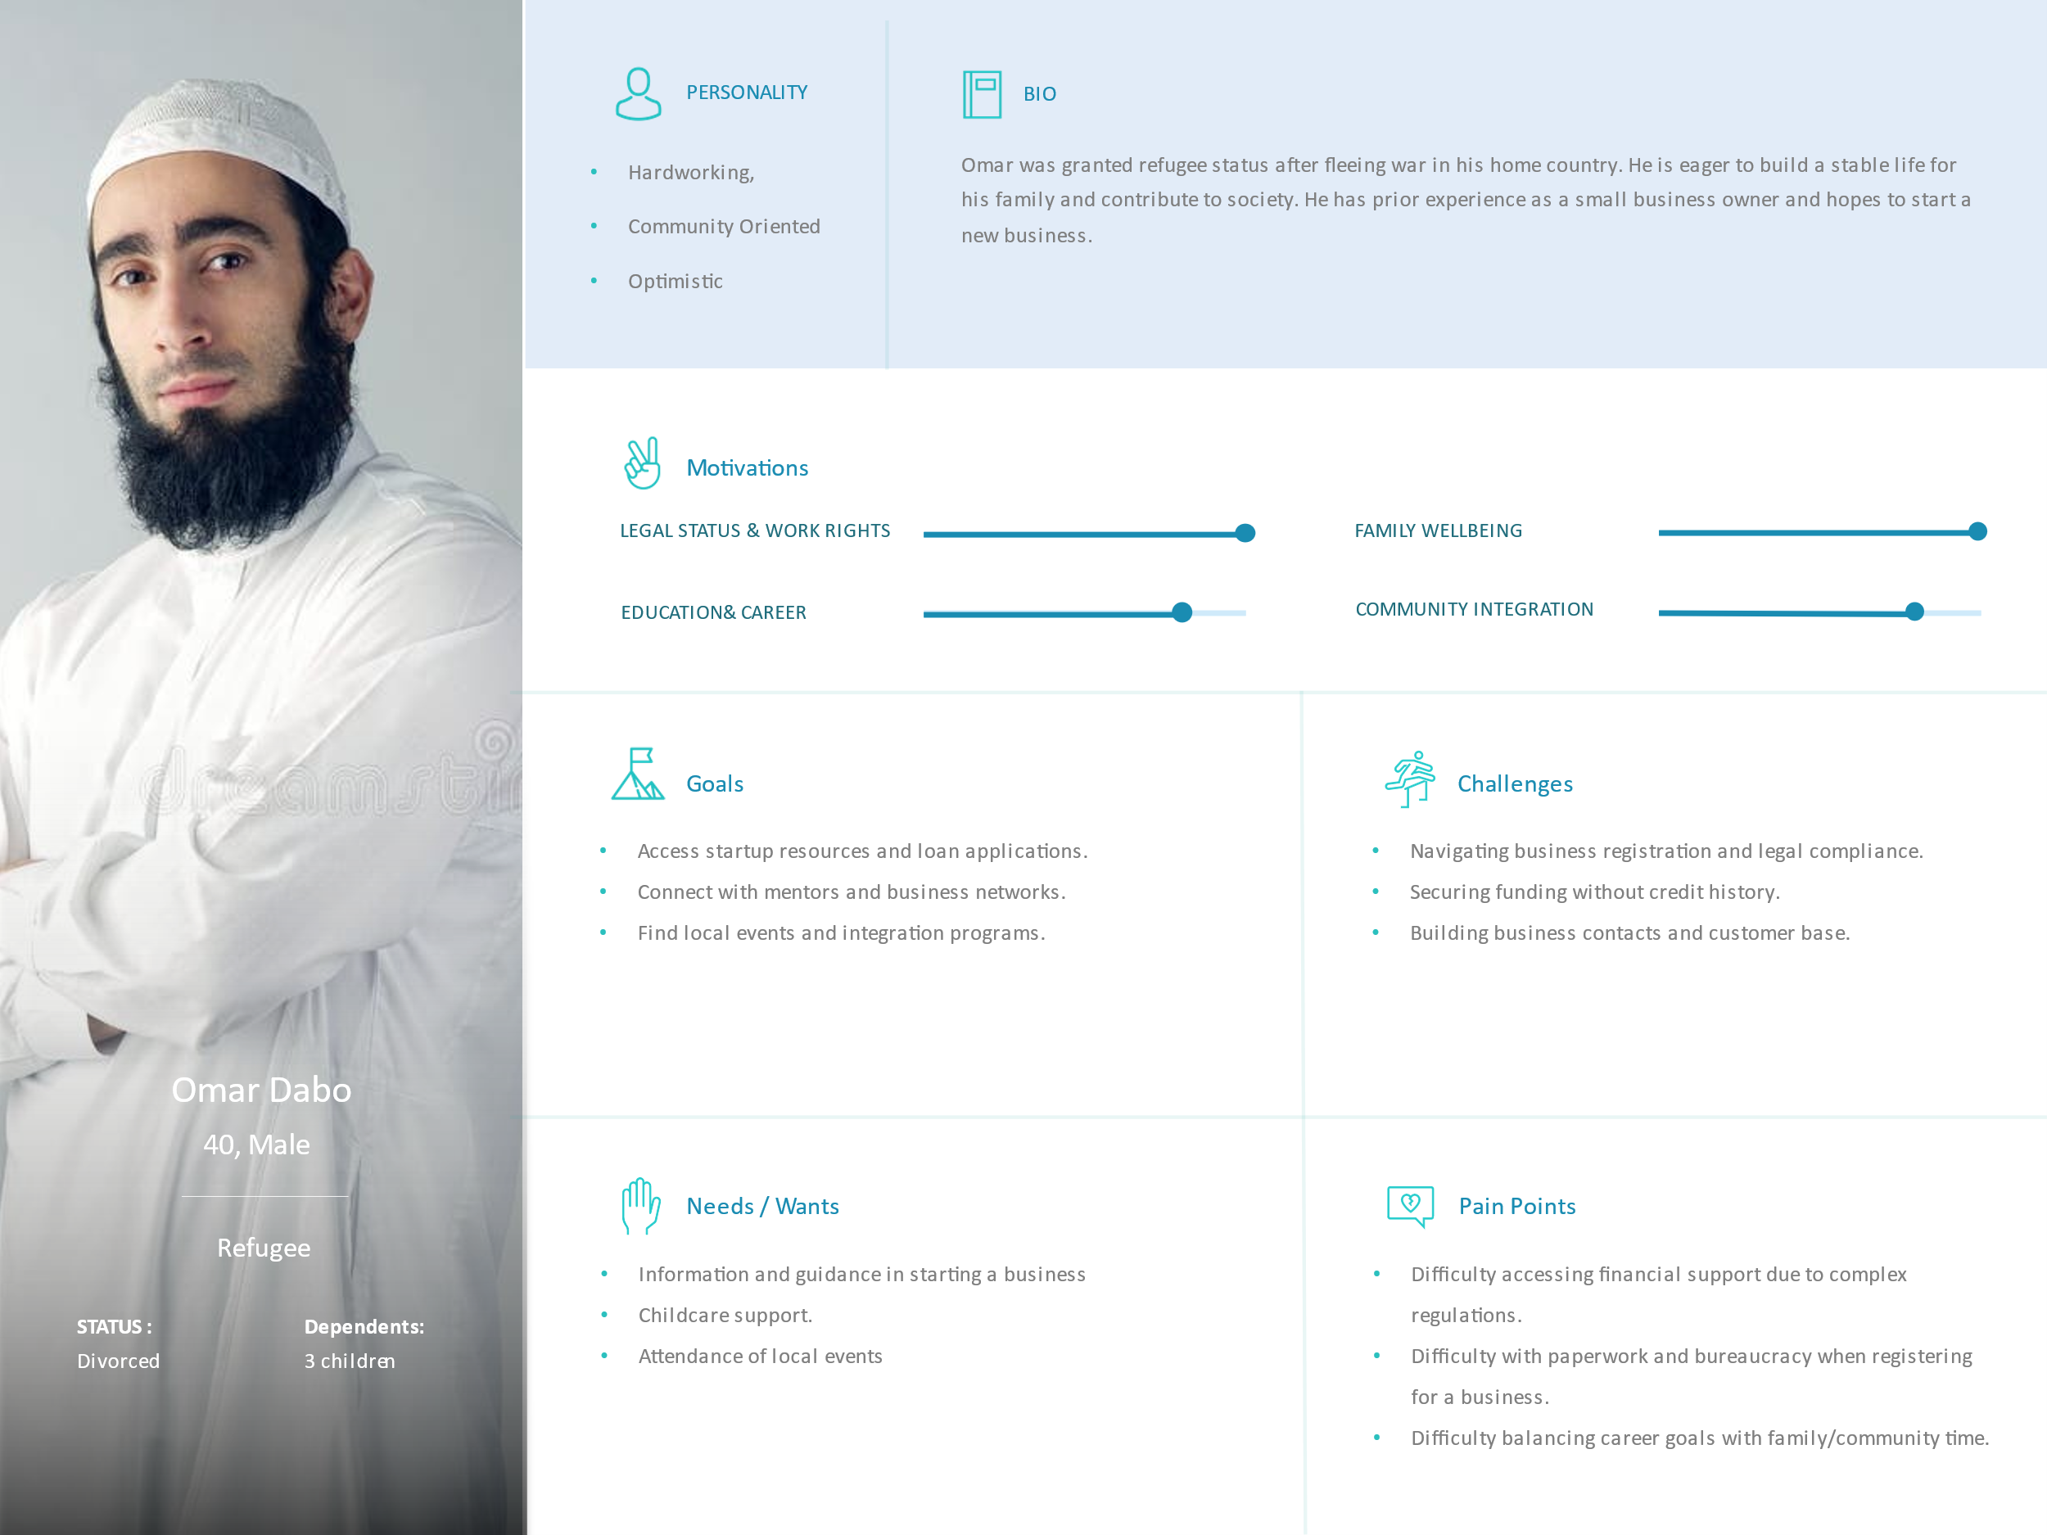

* How the web application addresses needs:
  + Provides access to startup guides, legal templates, financial aid resources.
  + Provides access to support groups within online forums for childcare support
  + Provides an interactive local events calendar for networking and cultural integration.

**Persona 3**

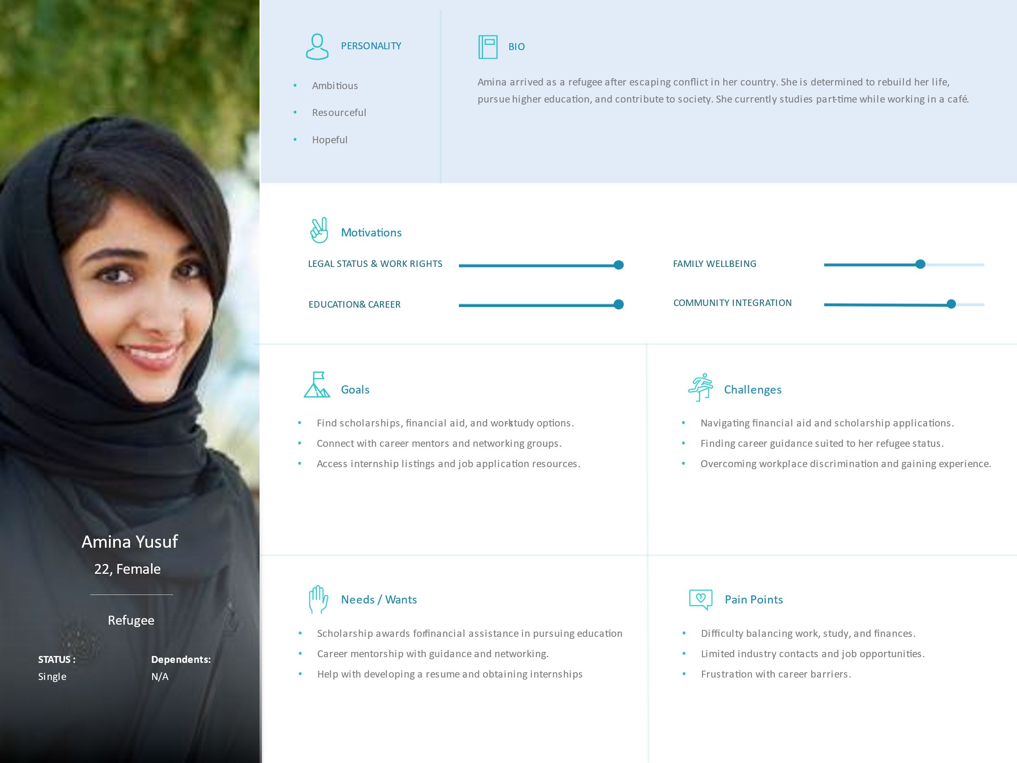

* How the web application addresses needs:
  + Provides access to scholarship information with refugee-specific grants.
  + Provides a platform for mentorship & careers guidance which connects mentors with mentees
  + Provides a job search tool with targeted filters to cater for a refugees situation / environment

## Section 3: Sitemap

**3. Sitemap**

*The sitemap is comprehensive, clearly organised, and effectively communicates the hierarchy and relationships between all main sections and sub-sections of the web application. The purpose of each main section is described concisely.*

Create a comprehensive sitemap using a tool like Draw.io or Lucidchart. Include:

* all main sections and sub-sections of the web application
* clear hierarchy and relationships between pages
* brief descriptions of each main section's purpose.

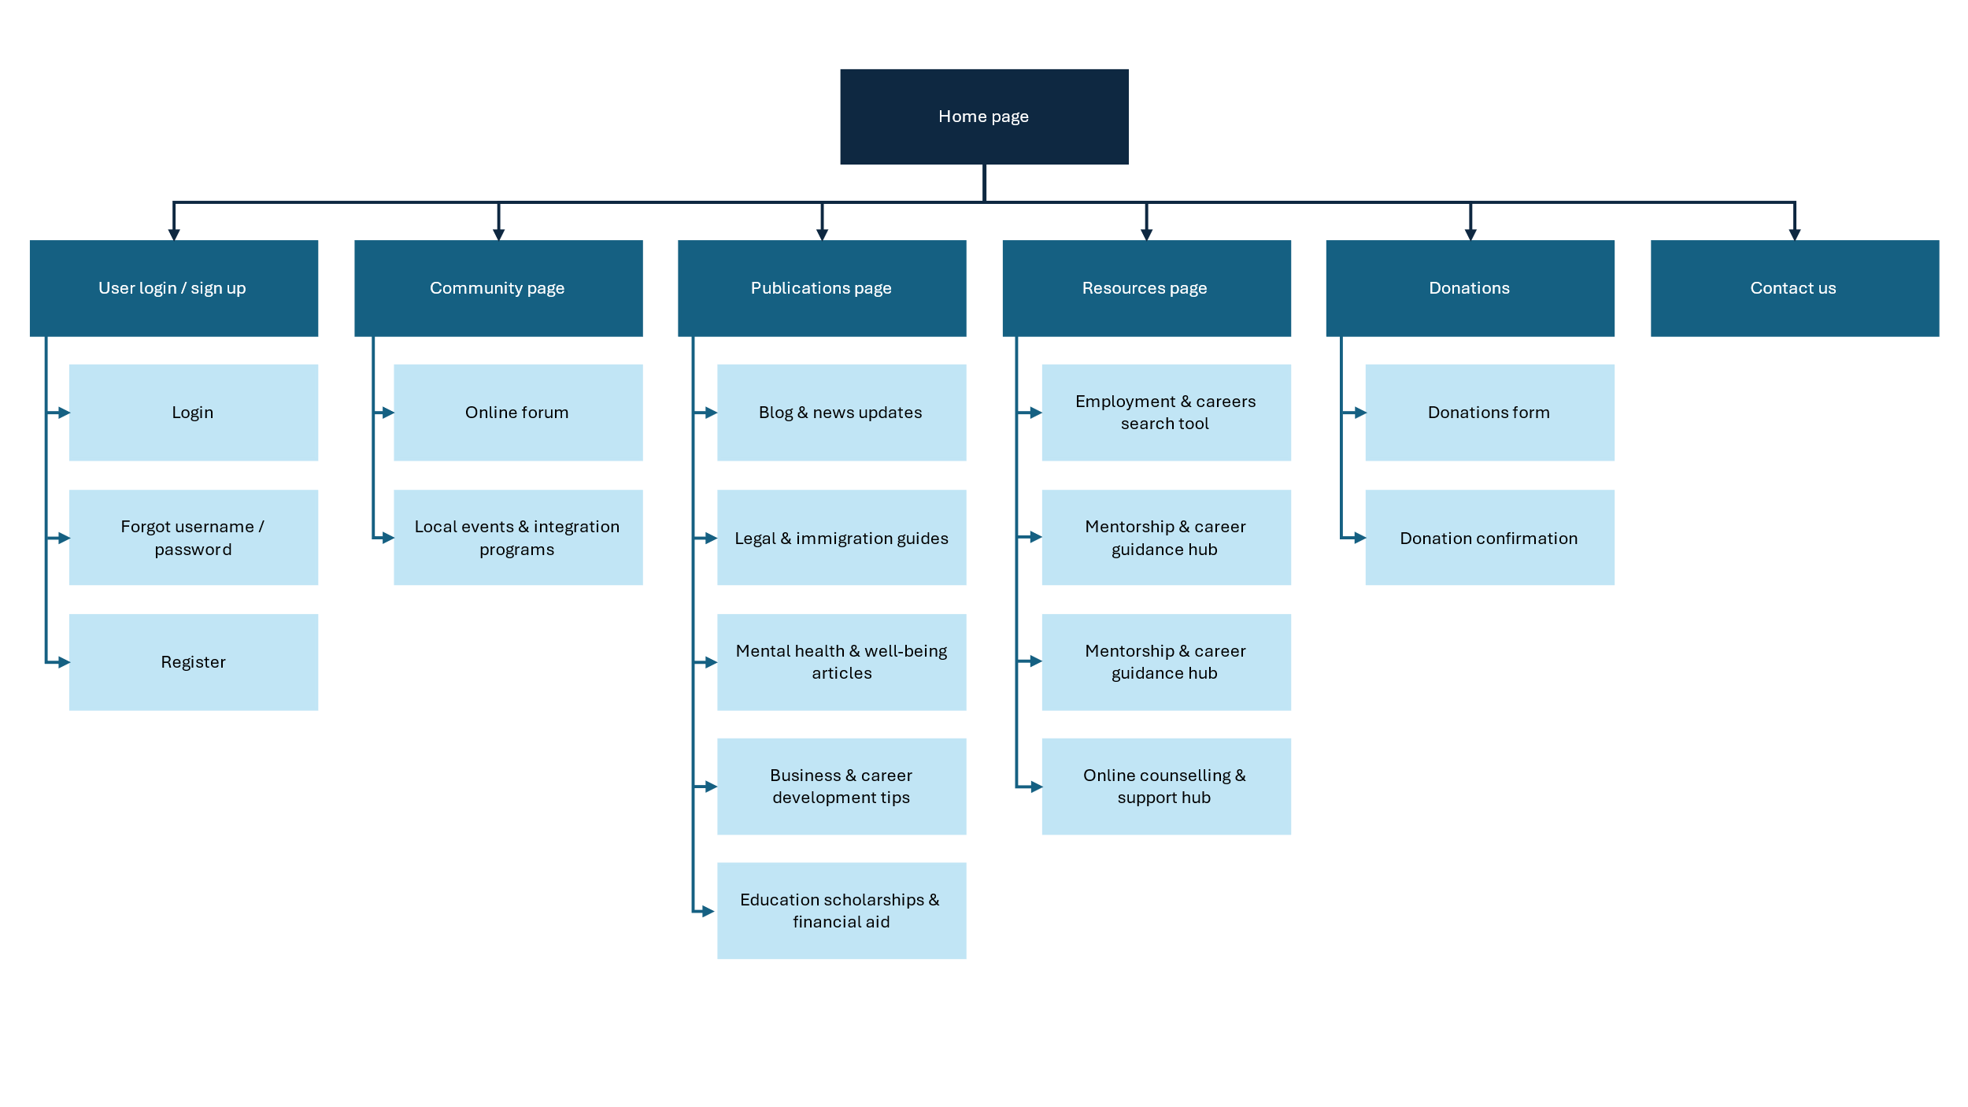

* User login / sign up:
* Community page:
* Publications page:
* Resources page:
* Donations:
* Contact us:

## Section 4: Wireframes/Low-fidelity prototype

**4. Wireframes/Low-fidelity Prototype (2–3 pages)**

*The wireframes/low-fidelity prototype demonstrate a clear understanding of the basic layout and interface elements of the web pages. The wireframes are well-executed, and effectively convey the structure and functionality of the web application.*

Include early sketches or wireframes that show the basic layout and interface elements of the web pages. Wireframes are crucial for visualising the structure before detailed design.

## Declaration: Additional Help

Any tools that you used (including Gen AI or existing code reuse) must be declared here.

**Note**: GenAI is not allowed for coding purposes in any assignment,

However, you may use GenAI for brainstorming and problem solving. You need to declare all such uses here. One row per help used.

|  |  |
| --- | --- |
| Name | Description |
| *Example: ChatGPT for brainstorming ideas* | *I used ChatGPT to brainstorm how to do X because I was feeling stuck with Y problem.* |
|  |  |